**Data Collection:**

**Collect the data:**

I collected the data from the Kaggle. The data set name is Airline dataset.

**Connect Data with Qlik Sense:**

For connecting the data with Qlik sense following these steps:

1. You should login to Qlik Cloud
2. Create an app
3. Upload the dataset on that App.

**Data Preparation:**

Preparing the data for visualization involves cleaning the data to remove irrelevant or missing data, transforming the data into a format that can be easily visualized, exploring the data to identify patterns and trends, filtering the data to focus on specific subsets of data, preparing the data for visualization software, and ensuring the data is accurate and complete. This process helps to make the data easily understandable and ready for creating visualizations to gain insights into performance and efficiency. Since the data is already cleaned, we can move to visualization.

Preprocessed dataset: https://0jo6i0sl5d074ft.sg.qlikcloud.com/dataset/6656245f1ce4e66bd1527294

**Data visualisation:**

It is a process to create a visualisation of data so that the user can easily understand the data. and it make data set /our app is more efficient.

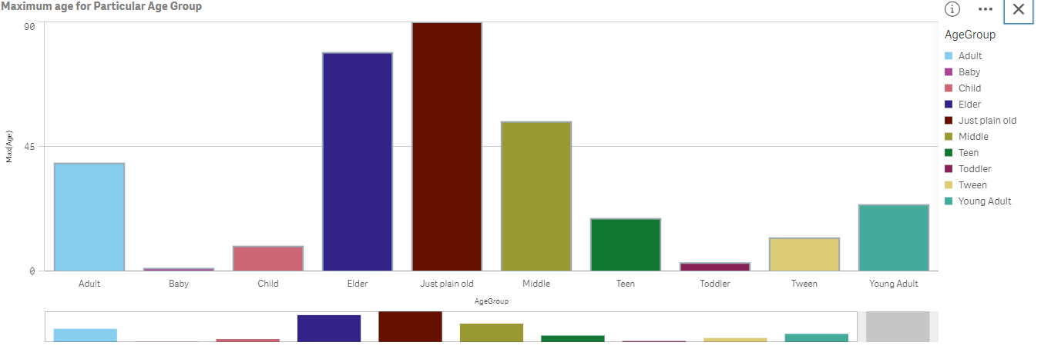

**Dashboard:**

A dashboard is a way of displaying various types of visual data in one place. Usually, a dashboard is intended to convey different, but related information in an easy-to-digest form. And oftentimes, this includes things like key performance indicators (KPI)s or other important business metrics that stakeholders need to see and understand at a glance.

Dashboards are useful across different industries and verticals because they’re highly customizable. They can include data of all sorts with varying date ranges to help you understand: what happened, why it happened, what may happen, and what action you should take. And since dashboards use visualizations Table, graphs, and Charts, others who aren’t as close to the data can quickly and easily understand the story it tells or the insights it reveals.

Some Dashboards are:

C:\Users\mehta\OneDrive\Desktop\Airlinedata Analysis\dashboard pdf.pdf

**Benefits of data dashboards:**

* A visual representation of performance
* The ability to identify trends
* An easy way of measuring efficiency
* The means to generate detailed reports with a single click
* The capacity to make more informed decisions
* Total visibility of all systems, campaigns, and actions
* Quick identification of data outliers and correlations